MINI ELECTRONIC VOTING MACHINE

A Project Report

Submitted in Partial Fulfillment of the Requirement
for the

ELECTRONICS & COMMUNICATION ENGG.

IN

DIPLOMA ^{th} SEM.

Prepared By

Ashwani Pandey (12211155)

Under the guidance of

Mr. Md. Asif Iqbal (Asst. Professor)

Department of Computer Application
LOVELY PROFESSIONAL UNIVERSITY, JALANDHAR 144411 PUNJAB.

ACKNOWLEDGEMENT

We take this opportunity to humbly express ours thanks fullness to although concerned with my project on ELECTRONIC VOTING MACHINE have been the product individual effort.

Instead they have been accomplished through the effort of many similarly , the outcomes of this project would be impossible without their co- operation. I express my heartily gratitude towards SWAMI SCHCHIDANAND POLYTECHNIC COLLEGE.
Who has given me an opportunity to develop this project in their organization. I am sincerely indebted to lecturer PANKAJ P. PRAJAPATI SIR, NILES K. PATEL SIR & PRAVIN M. PITHIYA.
Out internal guides for their consistence guidance & suggestion for the success of this project work. No project is created entirely by an individual many people helped to create this project and each of this contribution has valuable.
The timely completion of this project is mainly due to the interest and persuasion of our faculty. I am also thankful to all my friends for giving us valuable advise and knowledge of my work. Working on a project is hard need hard work and concentration this makes it possible

WITH REGARDS:

Ashwani Pandey (12211155)

INTRODUCTION

EVM stands for Electronics Voting Machine. It’s a lot different from the traditional ballot paper system both in terms of mechanism and performance. Its USP is its simple user interface. Even a person who never got a chance to go to schools can use it without much difficulty. The front panel shows all the candidates standing for the election along with their party symbols. There is a button corresponding to each of the candidates. To cast a vote just press the button beside to the candidate. A successful vote is indicated by a green light and a short beep.
There is a dedicated counter for each of the candidate ,which is placed inside. With each vote the counter corresponding to the candidate increases and is displayed through a LCD screen. This arrangement is kept under lock. After the election’s over the polling officer can open the lock and view the votes and declare the result

CIRCUIT DIAGRAM

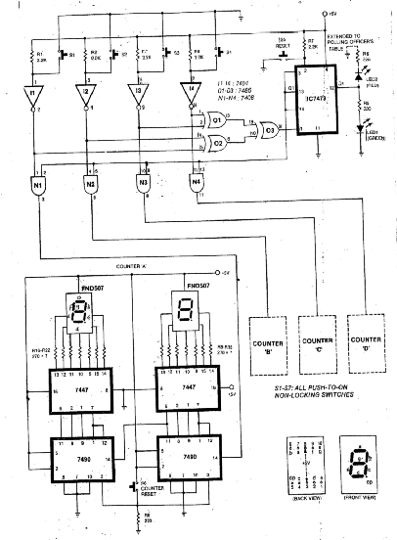

PCB LAYOUT OF CIRCUIT

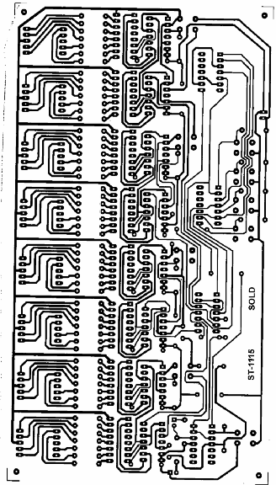

CIRCUIT DESCRYTION

- SWITCH s1 to s4 are the four push –to-on type non locking switches. One for each candidate. vote casting is done by just pressing a corresponding switch.
- LED1 glows to indicate to the voter that his vote has been cast (recording).
- XORGATE (IC7486) prevents the votes can be cast two buttons are pressed simultaneously.
- IC7473 locks self once a vote has been cast and thus prevents multiple votes by a person. It simultaneously lights LED2 at polling officer’s table. Pin 13 of IC7473 goes ‘low’ as soon as a ‘valid’ vote recorded.
- This in turn blocks all AND gate to avoid further counting of votes till the officer in charge reset the system through switch S7 at his table.
- Resetting of S7 should be done only when the voter has come out of the both after casting his vote.
- The counting of votes is carried out by the counters wired using IC 7490.Only ‘unit’ and ‘tens’ positions are shown.
- Depending on the number of voters expected the hundredth and the thousandth positions can also be wired.
- The votes corresponding to S1-S4 are counted by counters C1-C4, respectively.
- Switch S6 must be keep under a lock and key arrangement.
- It should be reset before the voting starts and should not be disturbed there after till the voting is over and the results have been declare.
- Counters will store the digits as far as supply continues without failure.
- So on interrupted +5V supply derived from a battery is advisable.
- This machine can be used in school , college election.

  - COMPONENT LIST

- IC (INTERGRATER CIRCUIT):-
1. IC 7404.
2. IC 7486.
3. IC 7408.
4. IC 7473.
5. IC 7447.
6. IC 7490.

- SWITCH:-
S1 - S6 PUSH –TO-ON NON BLOKING
SWITCHES.

- RESISTOR:-
R1 - R4 , R7 -2.2KΏ.
R5, R6, R8:- 220Ώ.
R9 – R22 :- 270Ώ.

- LED(LIGHT EMITTING DIODE):-
RED LED.
GREEN LED.

- DISPLAY:-
FND 507 SEVEN SEGMENT DISPLAY.

- RESISTOR:-

  - FUNCTION:-
Resistors restrict the flow of electric current, for example a resistor is placed I in
series with a light-emitting diode (LED) to limit the current passing through the LED
Example:
Symbol:-
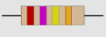

A Resistor as a passive component introduces Resistance i.e. Opposition to flow of current in a circuit. Resistor s are used in electronic circuits for setting biases, Voltage division, Controlling Gain, fixed time constants, matching and Loading circuit, Heat generation and related Applications.
R= PI/A
Where ,R is Resistance in ohm(Ω).
L (LENGTH) of conductor in.
A is Area of Cross-section of Conductor cm*cm.
P is Specific Resistivitely of the materials in cm.

Thus Resistance Depends upon Physical dimension of the Resistor and Resistively of the conducting material used.

  - Connecting and soldering :-
Resistors may be connected either way round. They are not damaged by heat when soldering.

  - Resistor values– The resistor colour code :-
Resistance is measured in ohms, the symbol for ohm is an omegaΩ. 1Ω is quite small so resistor values are often given in kΩ and MΩ. 1 kΩ = 1000Ω .
Resistor values are normally shown using coloured bands. Each colour
represents a number as shown in the table. Most resistors have 4 bands:
 The first band gives the first digit.
 The second band gives the second digit
 The third band indicates the number of zeros.
 The fourth band is used to shows the tolerance (precision) of the resistor.

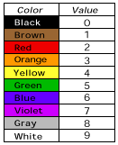
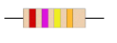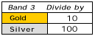

220 RESISTOR:- Typically 220 ohm ,1/4 watt resistor can be used with various circuit. The colour band of the resistor is Red, Red, Brown, Gold.

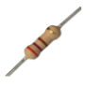
 Type: Carbon film resistor
 Tolerance: 5 %
 Size: 1/4 watt
 Value: 220 Ω
270 RESISTOR:- This resistor has red (2), violet (7), yellow (4 zeros) and gold bands. So its value is 270Ω = 270 Ω. On Symbol the Ω is usually omitted and the value is written 270.

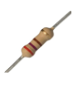
Typically 270 Ω,1/4watt resistor can be used with various circuit. The colour band is Red, Purple, Brown, Gold.
Type: Carbon film resistor
Tolerance: 5 %
 Size:1/4 watt
 Value:270Ω

- LED (LIGHT EMITTING DIODE)

- Principle:-
When PN junction is forward biased, electron in N- region combine with the holes in P- region. Free electrons are in the condu-ction band and holes are in the valence band. Thus electrons go to the valence band from the conduction band that is electrons go to the lower energy level from higher energy level. So when recombine-tion of electrons and holes occurs , energy is radiated in the from of heat and light.

- Symbol:-
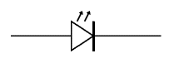
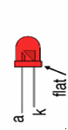

- Construction:-
N-type epitaxial layer is grown on the substrate. P-region is formed over it by diffusion process. Recombination of the charge carrier take place in P- type material such that the light is not obstructed. A layer of gold film is kept is below N- layer so that the light emitted is reflected. In symbol the arrows point to the outward side that the light is emitted.

- Working:
LED is forward biased to bring it into action. Minimum of 10 mA to 25 mA. Due to the forward bias, electrons from N-type material go from the conduction band recombination with the holes in the valence band of P- type material. So the energy of the from of light is rasiated.

- Advantages:-
- Efficiency: LEDs produce more light per watt than incandescent bulbs.
- Color: LEDs can emit light of an intended color filers that traditional mettodes require. This is more efficient and can lower initial costs.
- Size: LEDs can be very small and are easily populated onto printed circuit boards.
- On/off time: LEDs light up very quickly. a typical red indicator LED will achieve full brightness in microseconds. LEDs used in communications devices can have even faster response times.
- Cycling: LEDs are ideal for use in applications tht are subject to frequent on-off cycling, unlike fluorescent lamps that burn out more quickly when cycled frequently, or hid lamps that required a long time before restarting.
- Dimming: LEDs can very easily be dimmed either by pulse- width modulation or lowering the forward current.
- Cool light: in contrast to most light sources , LEDs radiate very little heat in the form of IR that can cause damage to sensitive objects or fabrics. Wasted energy is dispersed as heat through the base of the LED.
- Slow failure: LEDs mostly fail by dimming over time, rather than the abrupt burn- out of incandescent bulbs.
- Lifetime: LEDs can have a relatively long useful life . one report estimates 35,000 to 50,000 hours of useful life, thought time to complete failure may be longer.
- Shock resistance: LEDs, being solid state component, are difficult to damage with external shock, unlike fluorescent and incandescent bulbs which are fragile.
- Focus: the solid package of the LED can be defined to focus its light. Incandescent and fluorescent sources often require an external reflector to collect light and direct it in a usable manner.
- Toxicity: LEDs do not contain mercury, unlike fluorescent lamps.

- Disadvantages
- High initial price: LEDs are currently more expensive, price per lumen, on an initial capital cost basis, than most conventional lighting technologies.
- Temperature dependence: LED performance largely depends on the ambient temperature of operating environment. Overdriving the LED in high ambient temperature may result in overheating of the LED package, eventually leading to device failure.
- Voltage sensitivity: LEDs must be supplied with the voltage above the threshold and a current below the rating . this can involve series resistors or current –regulated power supplies.
- Light quality: most cool- white LEDs have spectra that differ significantly form a black body radiator like the sun or an incandescent light.
- Area light source: LEDs do not approximate a “point source” of light, but rather a lambertian distribution . so LEDs are difficult to use in applications requiring a spherical light filed.

  - Application:

- Visual signal application where the light goes more or less directly form the LED to the human eye, to convey a message or meaning.
- Lamination where LED light is reflected from object to give visual response of these objects.
- Finally LED also used to generate light for measuring and interacting with processes that do not involve visual system.
- As pilot indicator.
- In opto isolators.
- In large numerical display.

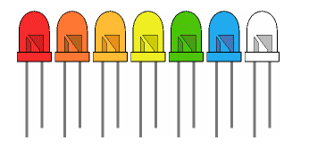
- LED TYPES:-

COLOUR | WAVELENGTH (nm) | VOLTAGES(v) | MATERIALS
RED | 610<ג<760 | 1.63<v<2.03 | GaAsP, AlGaInP, GaP
GREEN | 500<ג<570 | 1.9<v<4.0 | InGaN, Gap, AlGaInP

- SEVEN SEGMENT:-

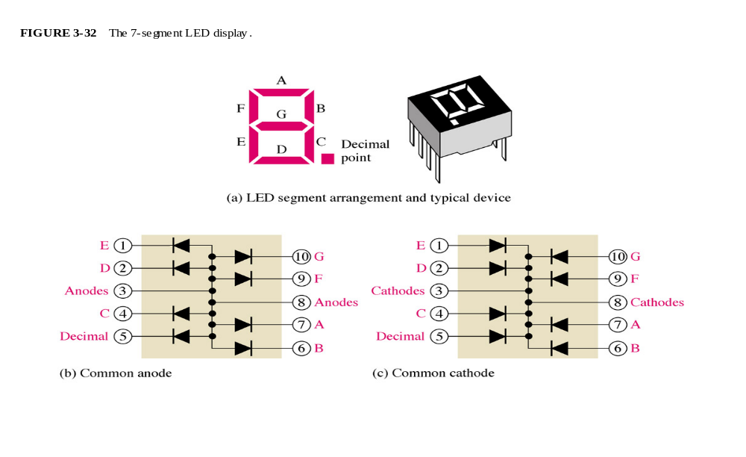
A seven-segment display (abbreviation: "7-seg(ment) display"), less
commonly known as a seven - segment indicator, is a form of electronic
Display device for displaying decimal numerals that is an alternative to the
more complex dot-matrix displays. Seven-segment displays are widely used in digital clocks electronic meteters , and other electronic devices for displaying numerical information.
In a simple LED package, each LED is typically connected with one terminal to its own pin on the outside of the package and the other LED terminal connected in common with all other LEDs in the device and brought out to a shared pin. This shared pin will then make up all of the cathodes (negative terminals) OR all of the anodes (positive terminals) of the LEDs in the device; and so will be either a "Common Cathode" or “Common Anode" device depending how it is constructed

- SWITCHES

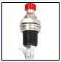
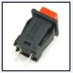

This looks like a momentary action push switch . when switch press than switch is in on condition. Push – to – on switch returns to its normally open position when you release the button, push –to- on switch return to its normally closed position when you release the button.
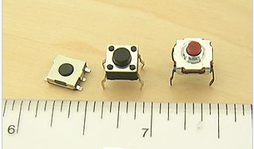
- Features of switch
- Contacts ( e.g. single pole , double throw)
- Ratings ( maximum voltage and current)
- Method of operation( toggle, slide, key etc.)
  - Switch contact ratings:
Switch contact are rated with a maximum voltage and current, and there may be different rating for AC and DC. The ac values are higher because the current falls to zero many times each second and an arc is less likely to form across the switch contacts.

For low voltage electronics project the voltage rating will not matter, but you may need to check the current rating . the maximum current is less for inductive loads because they cause more sparking at the contacts when switched off.

- +5v POWER SUPPLY:-

- POWER SUPPLY DESIGN
Power supply is the first and the most important part of our project. For our project we require +5V regulated power supply with maximum current rating 500mA
Following basic building blocks are required to generate regulated power supply.

Step-down transformer

Rectifier

Filter
Ckt.

Three
Terminal
Voltage req.

Regulated O/P
Voltage
Mains 230v A.C.

Figure 3.1: Circuit Diagram of Power supply design

- IC DATASHEET

- IC 7404

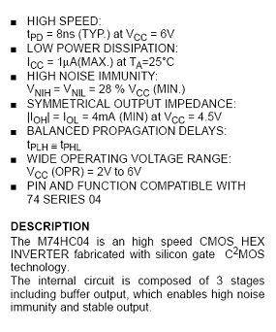
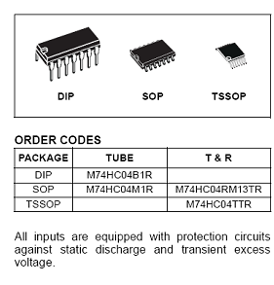
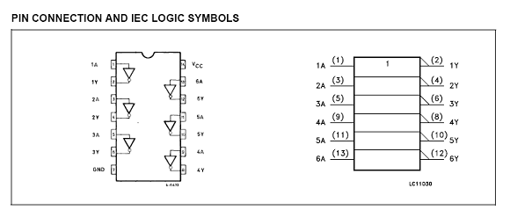

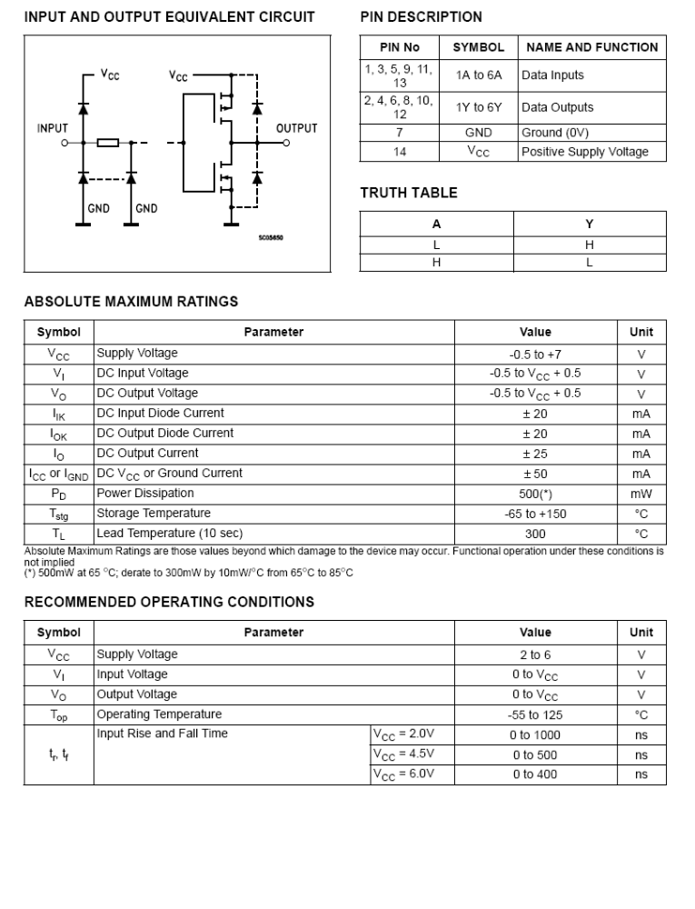

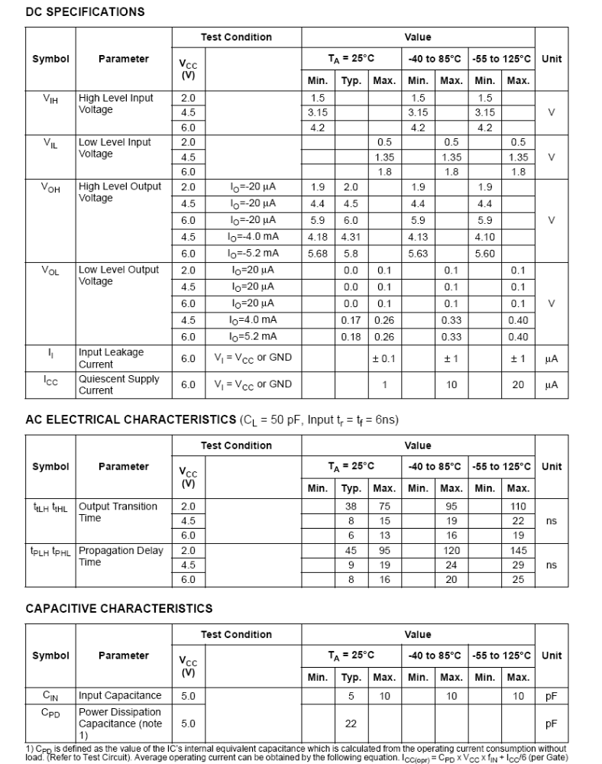

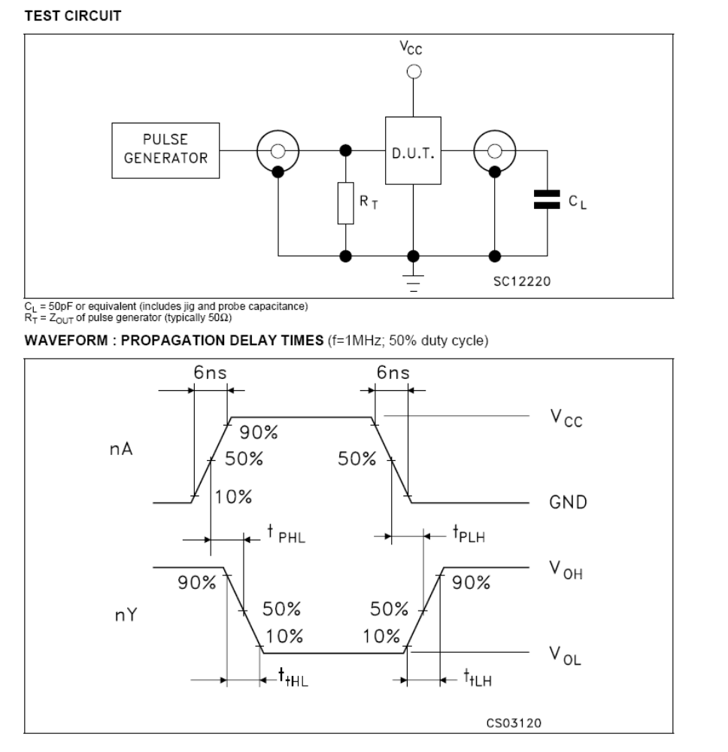

IC 7404 is a NOT gate, also called an inverter has only one input and, of
Course, only one output. NOT GATE Logic-Rules: The output is the inverse of the input, in other words if the input is HIGH then the out put is LOW and if the input is LOW the output is HIGH

- IC 7486

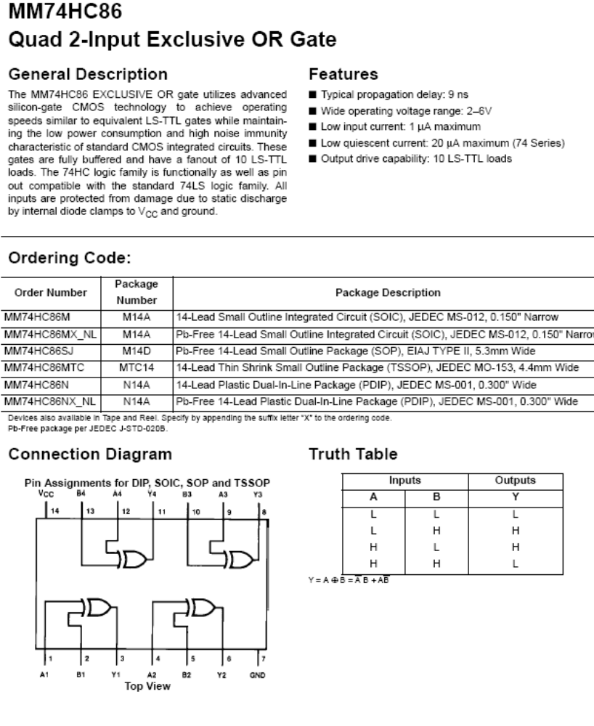

QUAD 2-INPUT EXCLUSIVE OR GATE:-
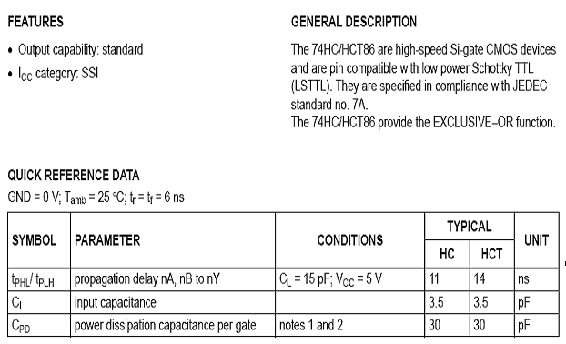
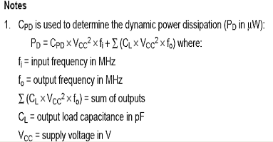
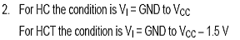

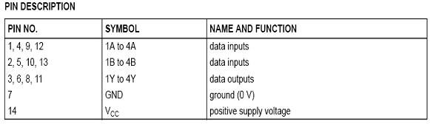

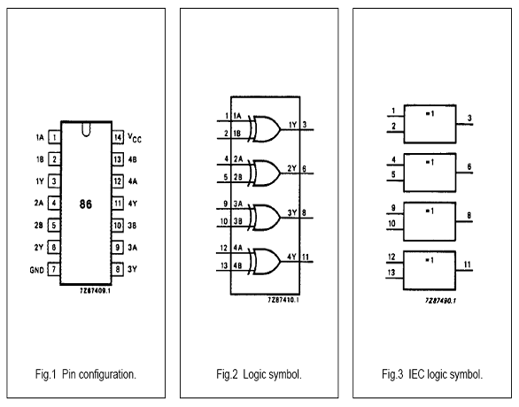

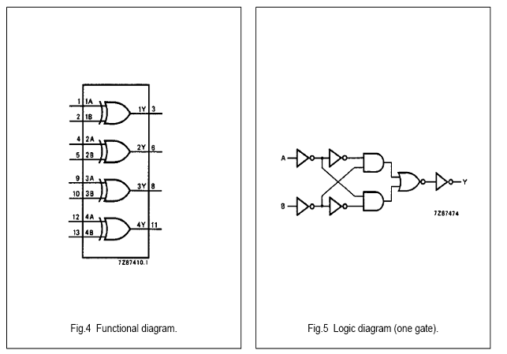

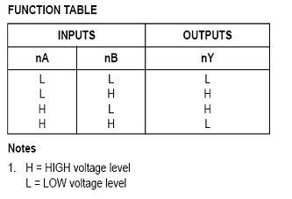
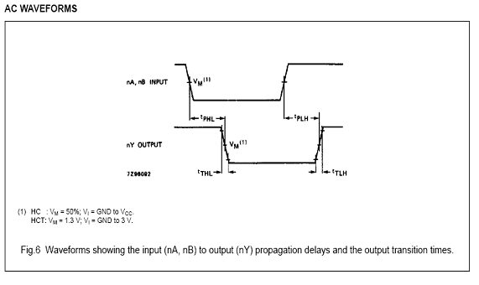

- IC 7408

IC 7408 is an AND gates has two or more input but only one output .It is also called an all or nothing gate. AND GATE Logic Rules: The output assumes the logic HIGH state , only when each of its input is at Logic HIGH state.
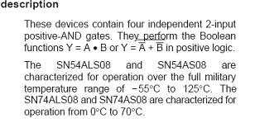
TOP VIEW OF 7408
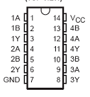
TOP VIEW OF IC 7408

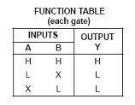
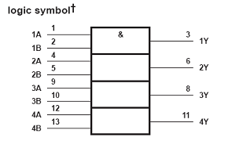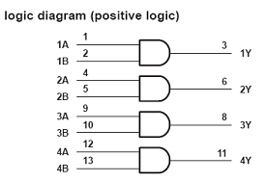
Absolute maximum rating over operating free-air temperature range:-

Supply voltage, vcc- 7v
Input voltage, vi- 7v

Load circuit wave form:-

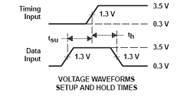
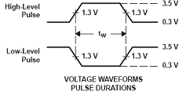

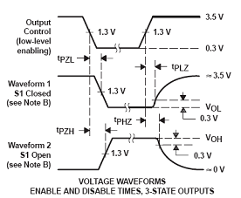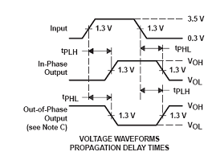

- IC 7473

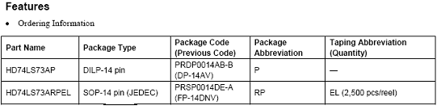

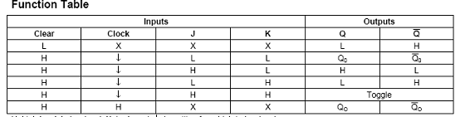

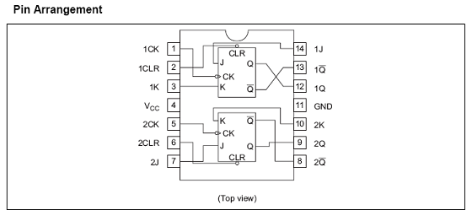

H= high level , L= low level
X= irrelevant , ↓= transition high to low
Q0= steady – state input condition
Q0 bar=compliment of Q0

- BLOCK DIAGRAM:-

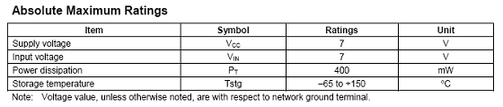

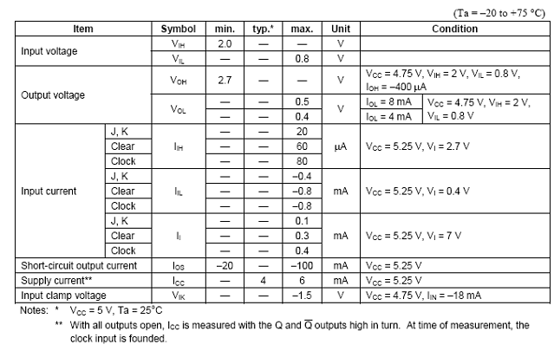

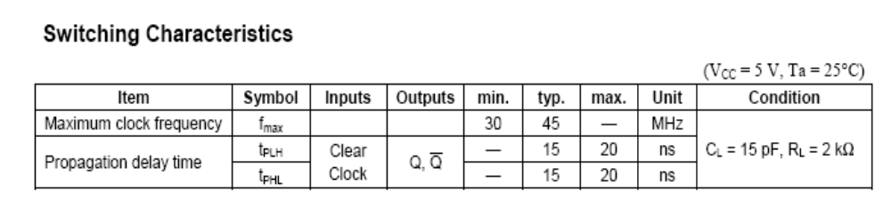

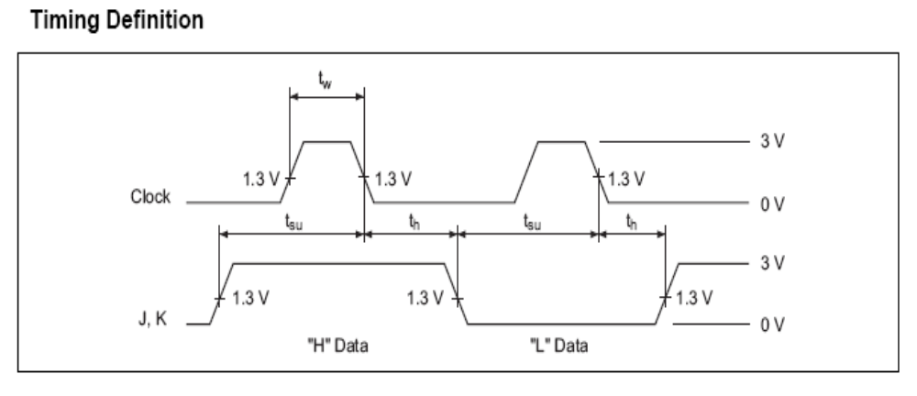

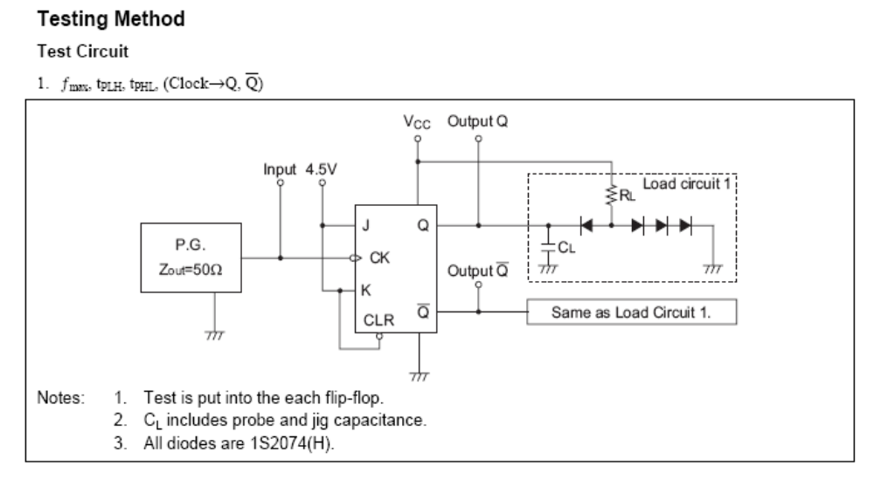

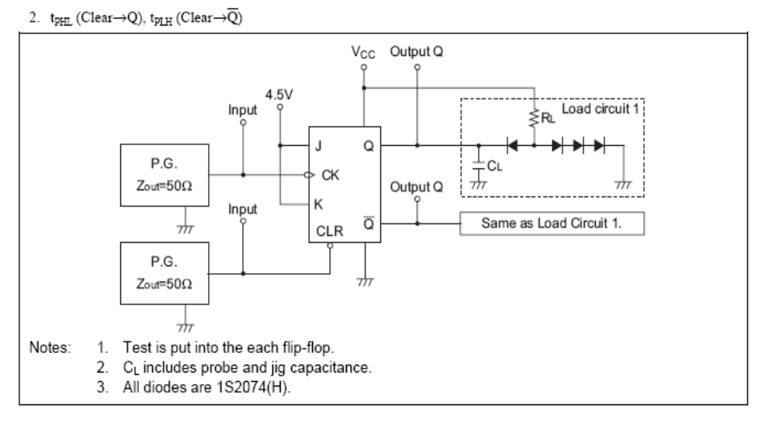

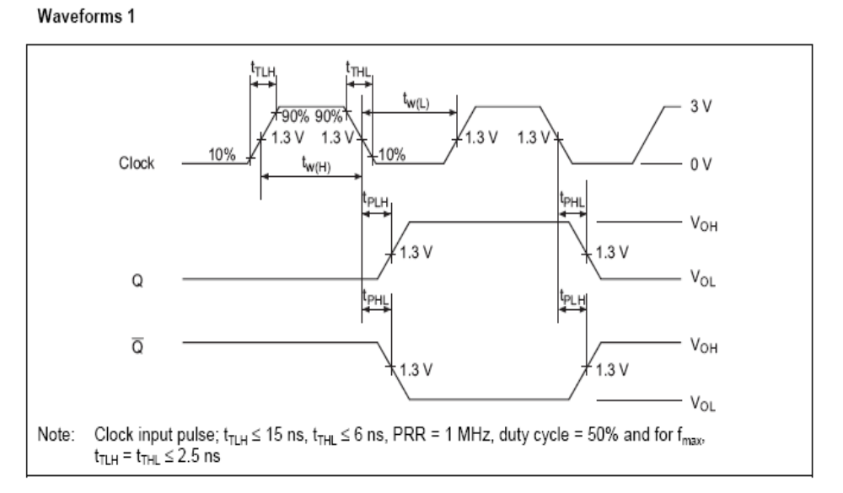

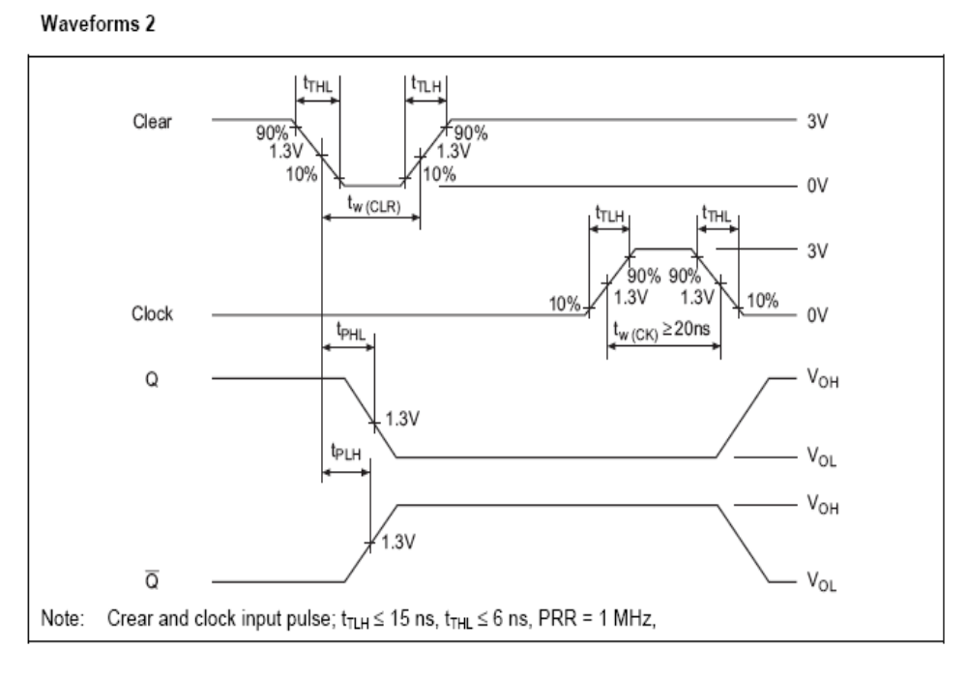

- IC 7447

TOP VIEW OF IC 7447
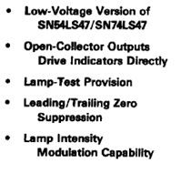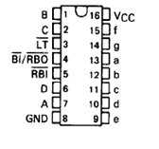

  - DESCRYPTION
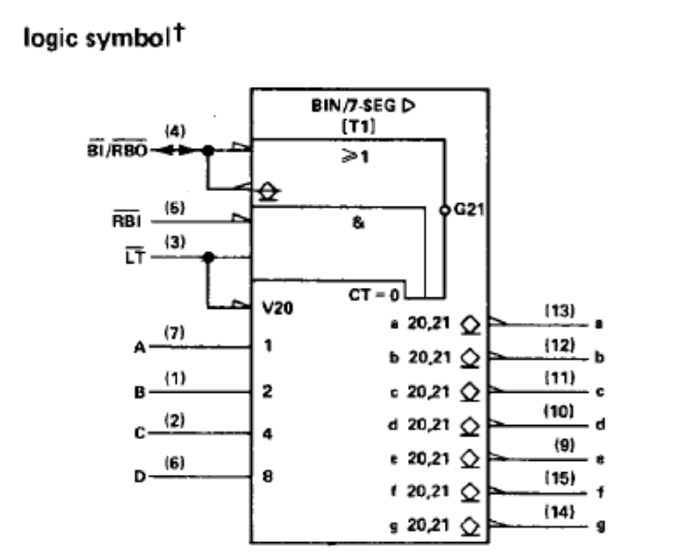
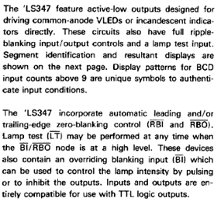

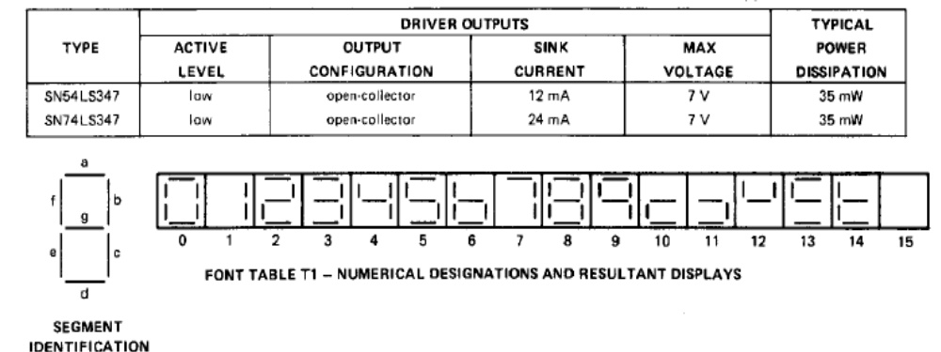

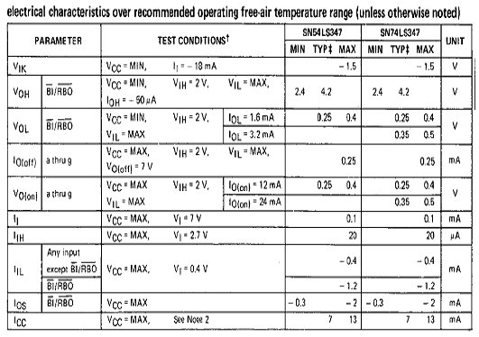

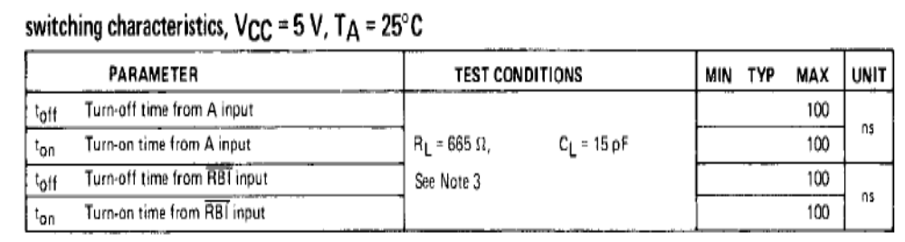

- IC 7490

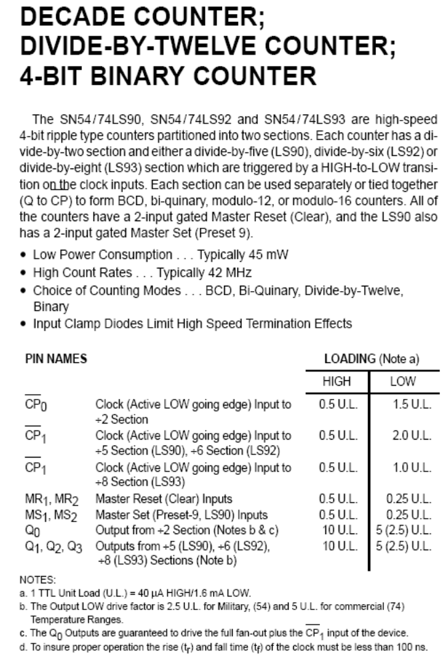
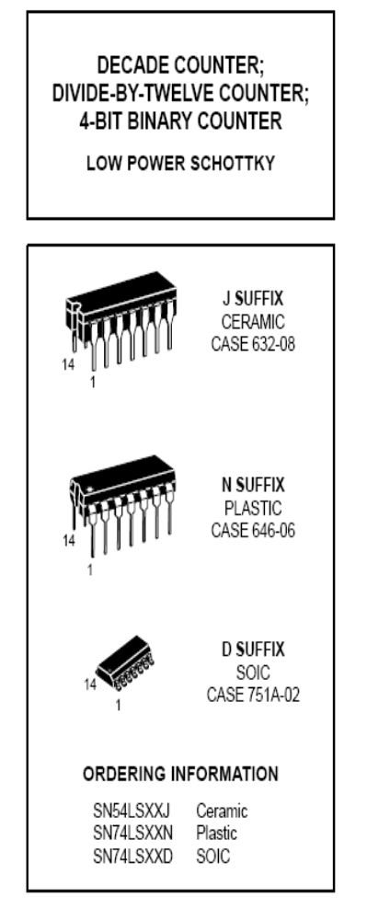

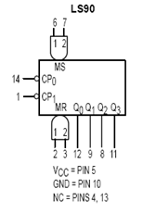

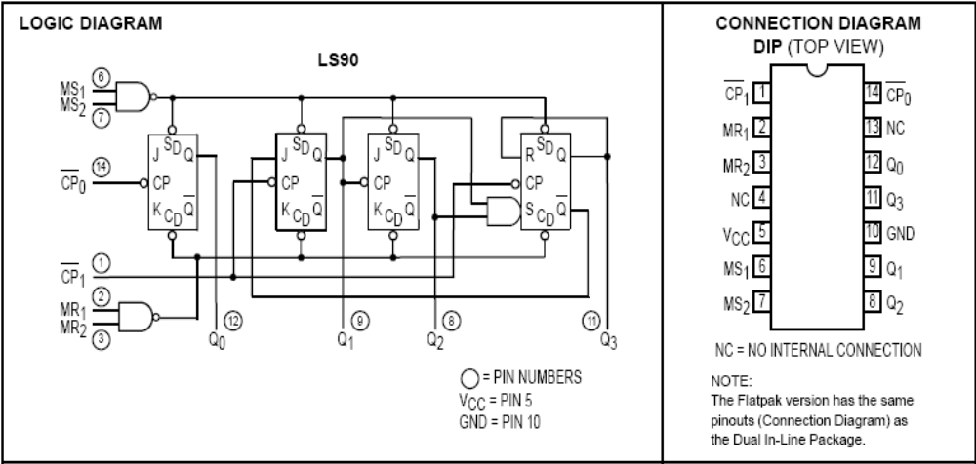

  - SN 74LS90

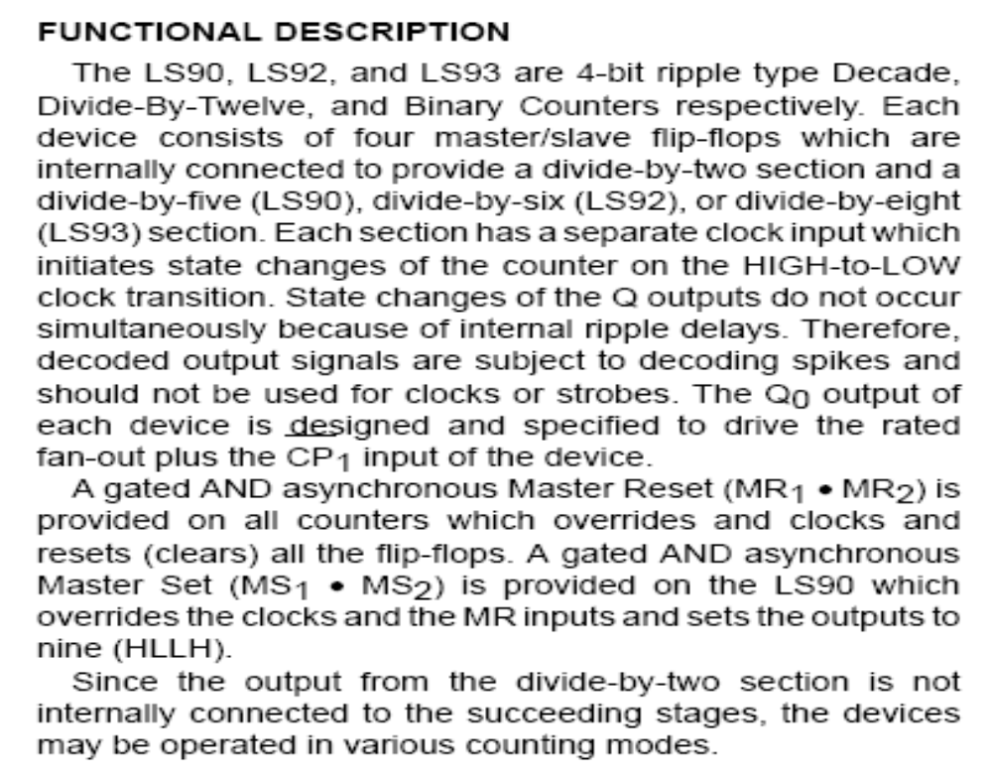

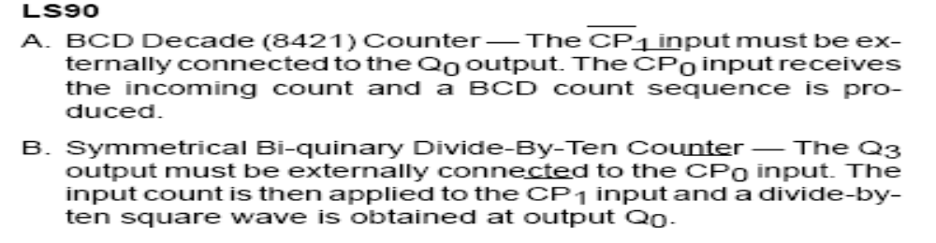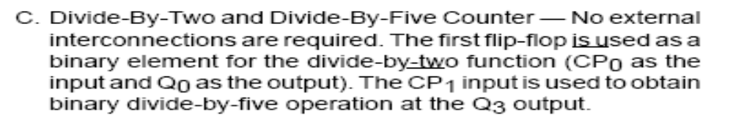

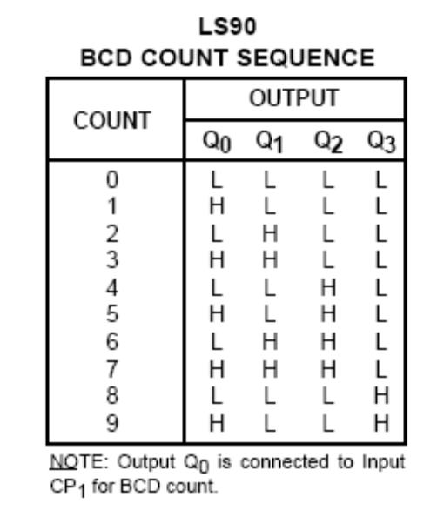
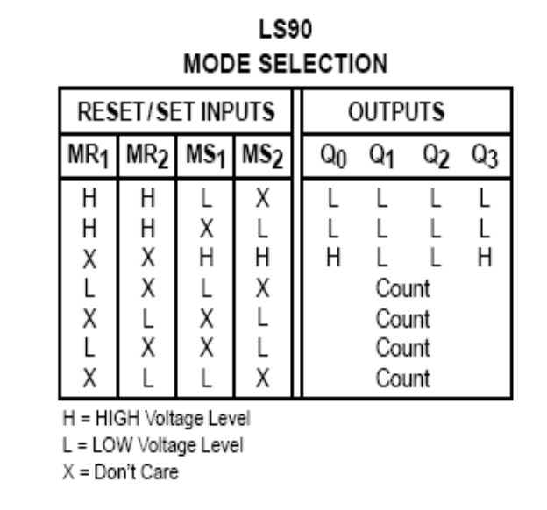
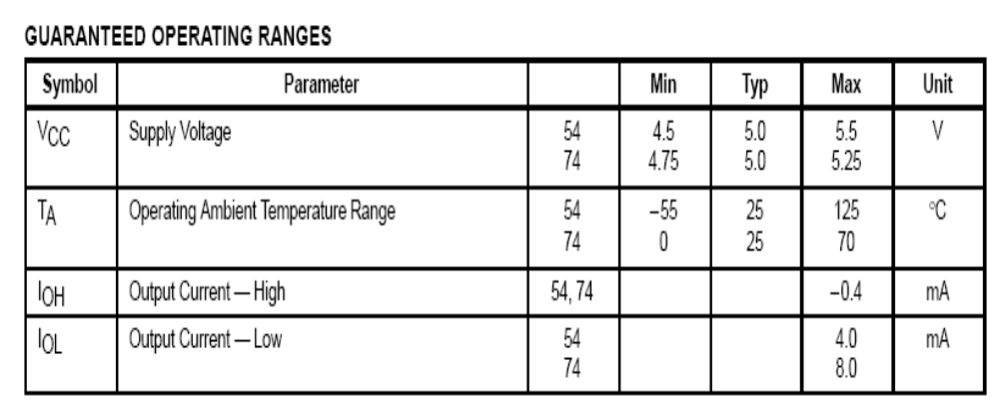
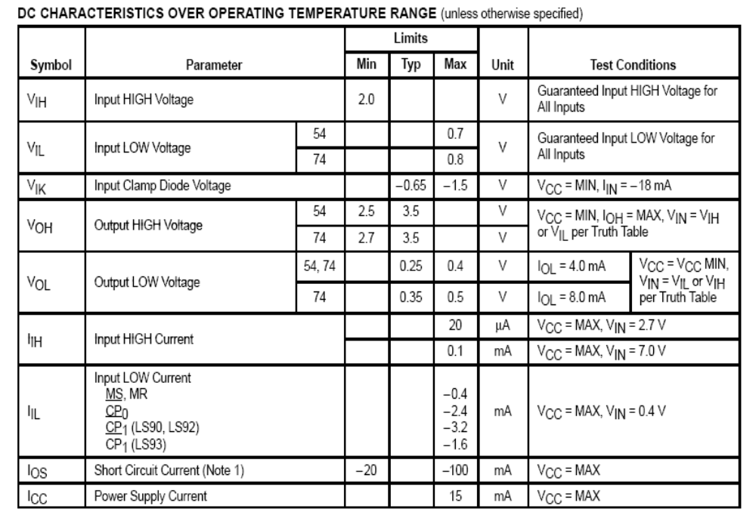

RECOVERY TIME:-It is defined as the minimum time required between the end of the reset pulse and the clock transition from HIGH-to-LOW in order to recognize and transfer HIGH data to the Q output.
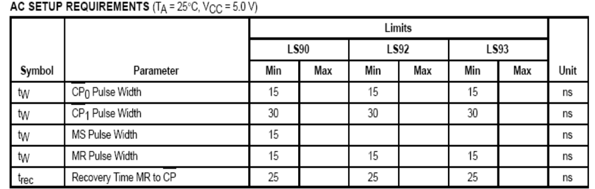
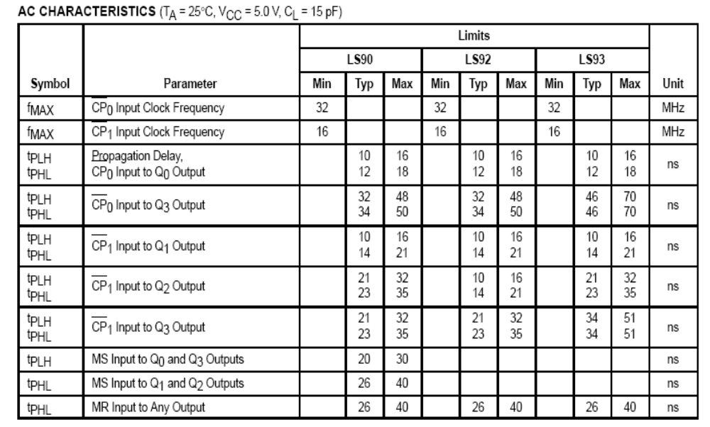

- WAVE FORM:-
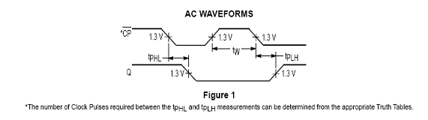
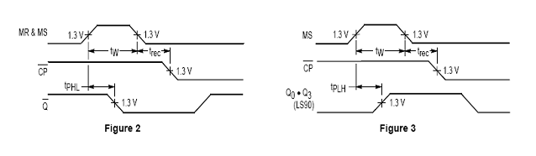

- ETECHING THE PCB

1. First, draw a layout circuit on the paper.
2. Then same layout is transferred copper side the PCB with help of carbon paper.
3. Then layout is color with the permanent marked or same other Permanent Marked.
4. After this drilling is done where the components are to be mounted.
5. The next step is to place PCB in the fed solution 20 to 30 minute then it is washed
With water.
6. The copper not marked with the marker is removed and with marked will
the marker is removed and with marked will remain the track will remain.
7. The blade then removes the marker on the tracks otherwise; it will result in the
Dry soldering.
8. Now the PCB is ready for the components mounting & Soldering.

- MOUNTING OF THE COMPONENT

1. After etching the component, the components are mounted on the printed circuit board.
All components are mounted on the holes.
2. Small resistors are mounted flat or horizontal and pushed through the correct
Mounting holes.
3. Recheck the color and symbol numbers where it mounts on the PCB.
4. First mounted IC socket in printed circuit board. Then it soldering and after soldering
IC mounted in IC socket.
5. Place the resistor in their position.
6. Switches is mounted in printed circuit board and then soldering it.
7. Small LED are mounted in the correct mounting holes. And then soldering.
9. Seven segment display is mounted in correct holes and then soldering it.

- SOLDERING :-

  - Soldering iron :-
The iron consist of an insulating handle connected via a metal shank to the bit.
The function of bit is to :
1. Store and deliver molten solder and flux.
2. Store heat and pass it to the compounds.
3. Remove extra solder from joints.
Soldering bit is made of copper because it has good heat capacity and thermal. Conductivity. Some iron have thermostatic control to keep the temperature of bit constant, various wattage such as 10 w 25 w,35 w,60 100w are available.
- Soldering flux :-
Flux is a medium used to improve the degree of wetting. The desirable
Properties of flux are:
1. It should provide a liquid cover for the material and avoid air gap to the Soldering temperature.
2. It should dissolve any oxide on metal surface.
3. It should be easily displaced from the metal by molten soldering
operation.
4. Residue should be removable after soldering operation.
The flux consists of Zinc Chloride or olive oil with active such as glycol acid, Ammonium chloride and organic acids. By adding activates , flow and activity is increased without affecting corrosion.
- Solder :-
The three grades of solder generally used for soldering are 40/60 , 50/50 ,60/40 etc of tin and lead respectively. The 60/40 w solder has high cost but it melts at lowest temperature, flow more freely, takes less time to harden and generally makes it easier to do good soldering job. Solder is generally available in the form of wire. Flux is also incorporated in solder wire itself. In such case no extra flux is necessary
- Soldering with iron :-
The surface to be soldered must be cleaned and fluxed . the soldering iron is switched on and allowed to attain soldering temperature . the solder in the form of wire is applied near the component and heated with iron. The surface to the solder are fitted , iron is removed and joints are cooled without any disturbance.
The following are the advantage of soldering :
1. A good soldering provides a good permanent resistance path .
2. Makes good electrical link between PCB and leads of component.
3. Retain the required strength with temperature variation.

- ADVANTAGES :-

1. Simple user interface.
2. Less cost
3. Quick results
4. Fair elections
5. Tamperproof

- DISADVANTAGES :-

1. Limited no. of candidates.

2. More candidates mean implies complicated circuit.

- APPLICATIONS :-

1.It is used in general elections for choosing candidates to represent people at various stages.
2. It can be used in school ,college student union elections.
3. It can be used to find the general opinion of people on various issues.
4. Anywhere where majority opinion is to be found out

- CONCLUSION:-

The Electronic voting machine helped the voter
to cast his vote in a hassle free manner and for the poling officer it
proved to be a more convenient way to count the votes and declare
the result.

- REFERENCE:-

  - WWW.PROJECT.COM
  - WWW.DATASHEET.COM
  - WWW.DETAIL OF RESISTOR.COM
  - WWW.DETAIL OF SWITCH.COM
  - WWW. DETIL OF LED.COM
  - WWW.EFY.COM
  - VOLUME SIX

